

UNIVERSIDAD AUTÓNOMA DE NUEVO LEÓN

Escuela Industrial y Prepa Técnica Pablo Livas

Laboratorio de 3ra y 5ta Op. de **Inglés 3**

Semestre Enero-Junio 2018

Name: _________________________________. Group: ______. Date: _________.

**1.- TOPIC: FIRST CONDITIONAL**

The first conditional has the [**present simple**](http://www.perfect-english-grammar.com/present-simple.html) after 'if', then the [**future simple**](http://www.perfect-english-grammar.com/simple-future.html) in the other clause:

* if + present simple, ... will + base form

It's used to talk about things which might happen in the future. Of course, we can't know what will happen in the future, but this describes possible things, which could easily come true.

* If it **rains**, I **won't go** to the park.
* If I **study** today, I**'ll go** to the party tonight.
* If I **have** enough money, I**'ll buy** some new shoes.
* She**'ll be** late if the train **is** delayed.
* She**'ll miss** the bus if she **doesn't leave** soon.
* If I **see** her, I**'ll tell** her.

**Complete the Conditional Sentences putting the verbs into the correct form.**

1. If you (send) _____________ this letter now, she (receive)  ___________it tomorrow.
2. If I (do) ____________ this test, I (improve) _______________ my English.
3. If I (find) _____________ your ring, I (give)______________  it back to you.
4. Peggy (go) ____________ shopping if she (have) ___________ time in the afternoon.
5. Simon (go)_____________  to London next week if he (get)_________  a cheap flight.
6. If her boyfriend (phone / not)  __________today, she (leave)______________  him.
7. If they (study / not)  ______________harder, they (pass / not)  ____________the exam.
8. If it (rain)___________  tomorrow, I (have to / not)  ______________water the plants.

**Match the sentence beginnings and endings. Type the letter in the line.**

|  |  |  |  |  |  |
| --- | --- | --- | --- | --- | --- |
| **1____** |  |  | How will she get there | **A** | we won't give her a present. |
| **2____** |  |  | I'll go to university | **B** | if they offer it to her? |
| **3____** |  |  | Will your sister take the job | **C** | if I pass my exams. |
| **4____** |  |  | If Lucy doesn't invite us to her wedding, | **D** | if she can't get a flight? |
| **5____** |  |  | Jack will have a party on Friday | **E** | we'll go to the supermarket. |
| **6____** |  |  | If the local shop's closed, | **F** | if his parents go away. |

**2.- TOPIC: PARALLEL OR INTERRUPTED**

**PARALLEL**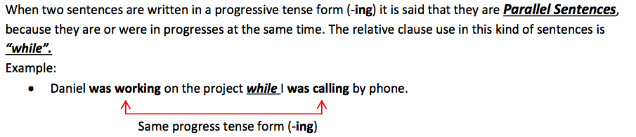

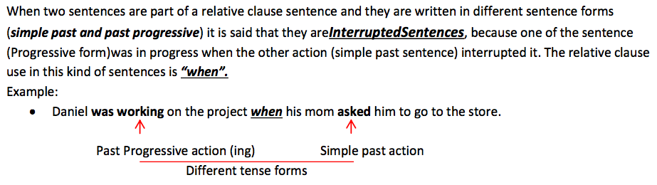 **INTERRUPTED**

**Choose the correct corret option Parrallel or Interrupted**

1.- ____________ The sun was shining when he got up

2.- _____________ While they were playing football, it was raining.

3.- _____________ When they were watching TV, a burglar came into the room and stole their money.

4.- ____________ Jack was walking down the street when he saw an accident.

5.- _____________ John was working in his room when heard a noise.

6.- ______________ I was studying while she was talking by phone.

7.- ______________ Simon was playing on the computer while his brother was

reading a book.

8.- _____________ Martha was arriving home, when the eathquake started.

**3.- TOPIC: PAST PROGRESSIVE**

The PAST PROGRESSIVE TENSE indicates continuing action, something that was happening, going on, at some point in the past. This tense is formed with the helping "to be" verb, in the past tense, plus the present participle of the verb (with an -ing ending):

I was riding my bike all day yesterday.

Joel was being a terrible role model for his younger brother.

|  |  |  |  |
| --- | --- | --- | --- |
| I | **WAS/ WASN´T** | PLAY**ING** | THE GUITAR |
| YOU | **WERE / WEREN´T** | PLAY**ING** | THE PIANO |
| HE | **WAS/ WASN´T** | PLAY**ING** | BASEBALL |
| SHE | **WAS / WASN´T** | PLAY**ING** | SOCCER |
| IT | **WAS / WASN´T** | PLAY**ING** | WITH THE BALL. |
| WE | **WERE / WEREN´T** | PLAY**ING** | IN THE HOUSE |
| THEY | **WERE / WEREN´T** | PLAY**ING** | WITH FRIENDS |

**Write positive sentences in past progressive.**

1.- My mother / read / a novel _______________________________________________

2.- My father / watch / a movie _______________________________________________

3.- My elder sister / writing / in her diary ________________________________________

4.- My two brothers / listen / to the radio ________________________________________

5.- My little sister and I / not / watch / a movie ____________________________________

6.- We / talk / about school ___________________________________________________

**Complete the sentences in past progressive.**

1.- She ______________ hockey. ( play)

2.- They______________  in the pool. ( swim)

3.- It __________________. (not / rain)

4.- We __________________ to music. (not/ listen)

5.- The mobile ___________________. ( ring)

6.- The students ____________________ . ( text)

7.- Max __________________ with two girls. ( dance)

8.- I  ____________________in front of the shop. (not / wait)

9.- The cat ________________ in the basket. ( sleep)

**4.- TOPIC: PHRASAL VERBS**

**Phrasal Verbs are idiomatic expressions, combining verbs and prepositions to make new verbs, whose meaning is often not obvious from the definition of the individual words.**

* + **Grow + up**
  + **Bring + up**

**Match the phrasal verbs with its definition.**

|  |
| --- |
| ra  a) become an adult |
| b) perform |
| c) create / invent |
| d) deliver |
| e) diminish in volume |
| f) move forward quickly |
| g) get involved |

Come up with _______

Turn down _________

Grow up ________

Get into _______

Drop off ________

Act out ________

Take off __________

**Complete with the correct phrasal verb.**

1.- Sandra _________________ in Argentina.

2.- Javier has to ________ the box to the following address.

3.- Johny Deep has to _________ as the main character of the movie.

4.- _______________the volumen please! My baby is sleeping.

5.- My brother always ________________ trouble because he is always late.

**5.- TOPIC: BE USED TO**

The ***be used to*** expression is for talking about something that is **familiar** to us or **easy** for us. For example:

is

are + used to    +   verb –ing

am

* *I am not used to****being****lied to.*
* *He is used to****working****late.*
* *We aren't used to****taking****the bus.*
* *Are you used to****cooking****?*

**Complete with the correct form.**

1.- they ________________ ( drink) milk .   
  
2.- Mrs Wilson _________________ ( read) four hours a day.  
  
3.- He is nervous because he ______________ (speak) English .   
  
4.- They _____________ ( have) lunch in a fast food every Saturday.   
  
5.- She lives in Los Angeles and she ______________ ( go) to Disney Land .   
  
6.- Don't worry about him, he ________________ ( get up) early every day .   
  
7.- Every day he ________________ ( tell) them stories before go to bed .   
  
8.- Mary ______________ ( walk) to school.  
  
9.- I _________________ ( collect) stamps .   
  
10.- He ________________ ( sing) in his bath .

Final del formulario

**6.- TOPIC: VOCABULARY**

**Draw or paste an image in each word or phrase.**

**Flat tire Landfill Spill oil**

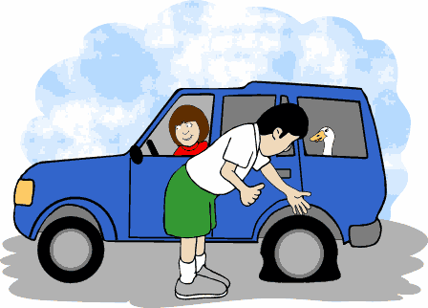

**Litter Get mugged Water pollution**

**Fumes Lie the sun**